We’re Just Here to Check-In

“We’re Just Here to Check In!”
Ministry of Academic Affairs 2024-25
Resources to Help With Coping Academically

Introduction and Purpose
"Let me hold the door for you.
I may have never walked in your shoes,
but I can see your soles are worn,
your strength is torn under the weight of a story
I have never lived before.
So let me hold the door for you.
After all, you’ve walked through it before."
— Morgan Harper Nichols
We're Just Here to Check In
This document is not here to present groundbreaking research or claim to have all the answers. It is simply an effort to bring together the resources and self-reference tips that might help, so you don’t have to spend time searching for them. We reached out to ACWB to verify all our information, ensuring that what we share is accurate and reliable.
Over the past weeks, many of you have shared the weight you are carrying—exams approaching, focus slipping, readings feeling impossible, work piling up, stress over grades, closed classes, brain fog, struggling with basic routines like eating or sleeping, feeling overwhelmed, anxious, or even guilty for trying to return to normal. We hear you. We see you. And above all, we want you to know you are not alone.
We are not preachers or therapists. We are just students looking out for other students. This document is a small way to let you know that we are here, and we’re in this together. Inside, you’ll find tools, strategies, and ACWB-approved resources to support you, whether that means managing coursework, handling stress, or simply knowing where to turn when things feel heavy.
Beyond this, Team MAA is trying its best, through all possible projects and resources during this period of academic stress, to further support you in any way we can. But for now, if you need a place to start, we hope this document can be that for you. And if you ever need more, please know that reaching out—to a friend, to ACWB, or even to us— can be part of this journey, too.

BRAIN FOG and HOW TO DEAL WITH IT
What is Brain Fog?
Brain fog is a term used to describe feelings of mental confusion, lack of clarity, and difficulty concentrating. It can make it hard to focus, remember things, or process information efficiently—almost like your brain is stuck in a thick cloud. It can be caused by stress, lack of sleep, poor diet, or even medical conditions.
- Ways to end Brain Fog
Brain fog can feel overwhelming, making even simple tasks seem exhausting. As college students, juggling deadlines, classes, and personal responsibilities can make it worse. Brain fog is not just “laziness” or a lack of effort—it’s a real cognitive challenge that many college students face.

Small, intentional changes can help lift the fog and restore mental clarity.

- Limit Screen Time and Take Breaks
Why it helps: Staring at screens for long hours can strain your eyes, overstimulate your brain, and disrupt cognitive function. The blue light from screens also suppresses melatonin, making it harder to sleep.
How You Can Implement This:
- Follow the 20-20-20 rule: Every 20 minutes, look at something 20 feet away for at least 20 seconds.
- Use screen time tracking apps like Forest or Freedom to manage usage.
- Take short breaks to stretch, walk, or simply rest your eyes.

- Manage Stress with Positive Thinking and Mindfulness
Why it helps: Chronic stress floods your body with cortisol, which can interfere with memory, concentration, and emotional balance. Mindfulness and reframing negative thoughts can significantly reduce stress and brain fog.
How You Can Implement This:
- Practice deep breathing: Try the 4-7-8 technique (inhale for 4 seconds, hold for 7, exhale for 8).
- Journal your thoughts— writing things down helps clear mental clutter.
- Use mindfulness apps like Headspace or Calm for guided meditation.
- Instead of saying, "I’ll never get this done," reframe it as "I can break this into small steps and make progress."

- Improve Your Diet for Better Brain Function
Why it helps: The brain consumes about 20% of the body's energy, meaning what you eat directly impacts cognitive performance. Highly processed foods, excessive sugar, and dehydration can contribute to brain fog.
How You Can Implement This:
- Prioritize brain-boosting foods like walnuts, avocados, and dark chocolate.
- Ensure you’re getting enough protein (eggs, lentils, lean meats) to maintain neurotransmitter function.
- Stay hydrated— even mild dehydration can impair focus. Aim for at least 2–3 liters of water daily.

- Get Enough Sleep (7–8 Hours Nightly)
[We know this is a tough ask in an environment like Ashoka, but please try it out!]
Why it helps: Sleep is when the brain processes information, clears toxins, and consolidates memories. Chronic sleep deprivation leads to slower thinking and difficulty retaining information.
How You Can Implement This:
- Aim to sleep at least before midnight— sleep quality is highest earlier in the night.
- Avoid screens at least 30–60 minutes before bed to improve melatonin production.
- If you struggle to fall asleep, try a wind-down routine: light stretching, reading, or listening to calming music.

- Exercise Regularly (At Least 30 Minutes a Day)
Why it helps: Physical activity increases blood flow to the brain, releases endorphins, and improves memory and focus. Research shows that students who engage in regular physical activity perform better academically.
How You Can Implement This:
- Try brisk walking, yoga, or dancing if you don’t enjoy traditional workouts.
- Even a 10-minute walk between study sessions can re-energize your brain.
2. When should brain fog be treated by a healthcare provider?
Let a healthcare provider know if you experience brain fog, especially if it’s disruptive to your daily activities and routine. You might want to talk to a provider if you frequently forget about appointments, have trouble completing ordinary tasks or find it difficult to pay attention when someone’s talking to you. Brain fog is common, and a provider can help you find out what’s causing your symptoms.

3. Developing a stress management plan can help with clearing Brain Fog.
- Set boundaries to protect time for self-care. [Yes, Ashoka has a lot of competition, but it is more important to practice self-care than attend another event or dorm gathering sometimes. Please prioritize yourself and that’s not selfish- it’s good!]
- Get comfortable saying “no” to requests for help when you’re already busy.
- Think of three ways that work for you to manage stressful situations anywhere. (Breathing exercises can be a good place to start.)
- Journaling about your mood and emotions.

STRESS OVER GRADES and WORK PILING UP: How to Deal with It

The pressure of deadlines, exams, and mounting assignments can feel overwhelming, but stress doesn’t have to control your academic experience. Stress over grades and workload is valid and real, but it doesn’t have to dictate your experience. Instead of seeing stress as a roadblock, use it as a signal to adjust your strategies.
- Rethink Your Approach to Productivity
Why it helps: Many students believe that working longer equals working better, but research shows that structured focus beats sheer hours spent studying. Cognitive overload from prolonged work sessions can reduce efficiency and increase stress.
How You Can Implement This:
- Try the "Two-Minute Rule": if a task takes less than two minutes, do it immediately (e.g.: responding to an email or organizing notes).
- Use task batching: group similar tasks together (e.g: answering emails, reading materials, and writing summaries) to minimize mental fatigue from switching between different kinds of work.
- Implement "productive procrastination": if you’re struggling with one assignment, switch to another easier one to maintain momentum rather than doing nothing.
- Keep a "win journal": write down small victories every day (e.g.: “I understood a difficult concept” or “I stayed focused for an hour”).
- Instead of aiming for perfection, focus on consistency. Progress, even if slow, is better than burnout from overexertion.

- Break Down Overwhelming Work with Smarter Study Strategies
Why it helps: Feeling overwhelmed often comes from not knowing where to start. Instead of tackling an assignment all at once, breaking it into manageable steps reduces procrastination and stress.

How You Can Implement This:
- Use the 5-Minute Start Rule: commit to working on a task for just five minutes. Often, starting is the hardest part, and once you begin, it’s easier to continue.
- Utilize active recall (quizzing yourself) instead of passive re-reading: it saves time and boosts retention.
- Create study sprints: work intensely for 40–50 minutes with a 10-minute movement break (this method is slightly longer than the Pomodoro technique but has been proven to improve deep focus).
3. Protect Your Mental Energy with Strong Boundaries
Why it helps: Saying “yes” to everything can lead to burnout. Setting clear limits on commitments and social obligations ensures that you have time for rest and deep work.
How You Can Implement This:
- Use the "3-Question Rule" before taking on extra work:
  - Does this align with my priorities?
  - Will I have enough time for my own needs?
  - Am I saying yes out of obligation or genuine interest?
- Practice "soft no’s": Instead of outright refusal, say, “I’d love to help, but my schedule is packed right now. Can I support in a smaller way?” [This is perhaps one of the most applicable tips for a setting like Ashoka.]
- Protect non-negotiable personal time for self-care, meals, and downtime.
4. Manage Work Overload Without Panic
Why it helps: A heavy workload can feel paralyzing, but strategic prioritization and mental resets can help prevent exhaustion.
How You Can Implement This:
- Prioritize based on impact, not urgency: focus on assignments that contribute the most to your goals rather than just what’s due first.
- Use "Stoplight Planning":
  - 🟢 Green: Tasks that require low effort but must be done (e.g., submitting forms).
  - 🟡 Yellow: Medium-priority tasks that need some focus (e.g., group discussions, outlining essays).
  - 🔴 Red: High-focus, high-priority work (e.g., exam prep, research papers).
- Take reset breaks: step outside, drink water, or listen to a song instead of pushing through when your brain feels stuck.
- Schedule one guilt-free recharge activity every day (e.g., watching a show, playing a game, or chatting with friends) to maintain balance.
- You can try using the Eisenhower Matrix to separate urgent vs. important tasks.
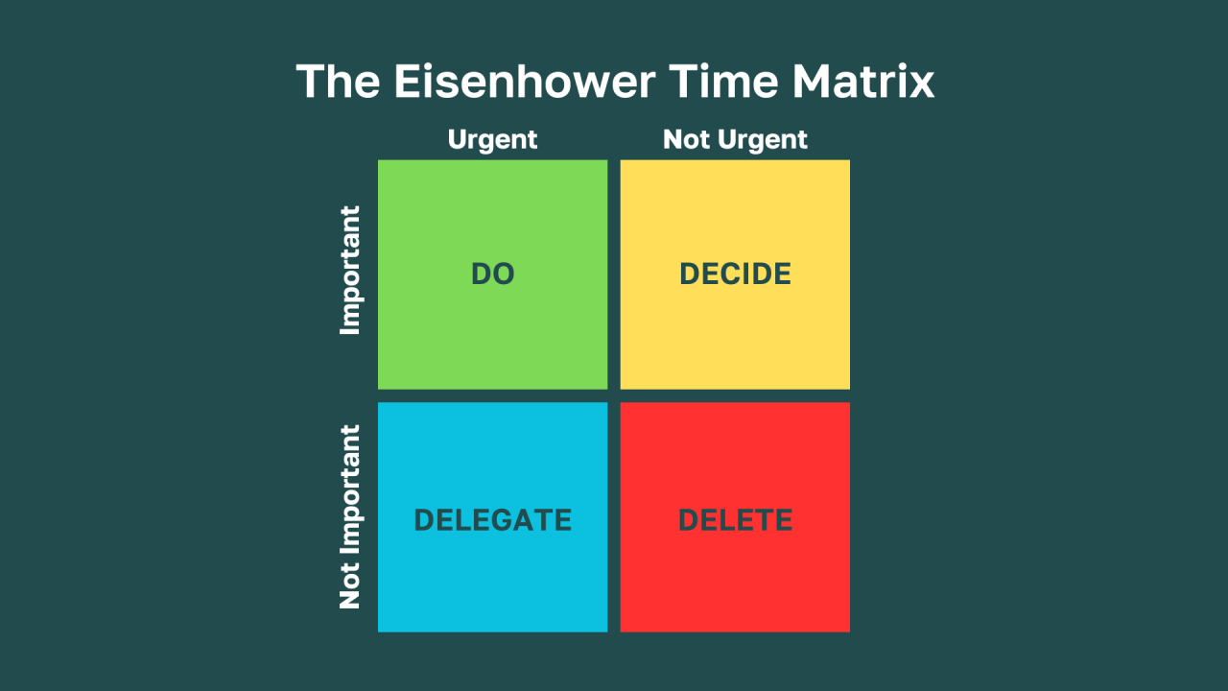
- Try the Pomodoro Technique (25-minute work sessions with five-minute breaks) to stay focused. You can use this website if you want to experiment with the Pomodoro technique: https://lifeat.io/room/BUN47oT06UcIWgA0?space=993

FOCUS ISSUES AS EXAMS COME CLOSER and How To Deal with it

Focus isn’t just about willpower: it’s shaped by your environment, habits, nutrition, and stress levels.

Ways to increase focus:
1. Optimize Your Study Environment for Maximum Focus
Why it helps: A cluttered desk or noisy space can unconsciously drain your mental energy. Research shows that too much visual clutter makes it harder for the brain to process relevant information, leading to distractions.
How You Can Implement This:
- Keep only essential items on your desk (e.g., laptop, notebook, water bottle) and remove unnecessary papers or objects.
- Study in minimalist environments: your dorm room, perhaps our library, or even in classrooms together.
- Experiment with ambient noise: some people focus better with white noise or instrumental music, while others need total silence.
2. Identify and Fix Attention Drains
Why it helps: Noticing when and why your focus drifts can help you address the root cause instead of just blaming yourself for being distracted.
How You Can Implement This:
- Track when your mind wanders: is it after 20 minutes? An hour? Does hunger, fatigue, or stress play a role? Identifying patterns helps you make targeted changes.
- Review medications and supplements: some can affect cognitive function. If you suspect an issue, consult a doctor rather than assuming it’s just “bad focus.”
- Be mindful of energy crashes: if your focus dips suddenly, check if it’s tied to blood sugar fluctuations (from consuming too much sugar or caffeine).

3. Use Time-Blocking for Structured Deep Work
Why it helps: Unstructured time invites procrastination. Time-blocking forces clear start and stop points, making study sessions feel more manageable and improving concentration.
How You Can Implement This:
- Set strict work and break intervals: e.g., 50 minutes of studying, followed by a 10-minute movement break.
- Mark study sessions as "busy" on your calendar to avoid interruptions from friends or notifications. Use website blockers (some include Cold Turkey, Freedom, Forest) for distractions.
- Plan mental resets: brief stretching, walking, or deep breathing between blocks to prevent cognitive fatigue.
4. Leverage Smart Nutrition for Mental Clarity
Why it helps: What you eat fuels your brain. High sugar or caffeine intake can cause sharp focus crashes, while brain-friendly foods boost cognitive performance.
How You Can Implement This:
- Swap sugary snacks for whole fruits, nuts, or yogurt to maintain stable energy levels.
- Stay hydrated: even mild dehydration can impair concentration.
- Avoid caffeine late in the day: it can disrupt sleep cycles, indirectly reducing focus the next day.
5. Experiment with Sensory Anchors for Attention
Why it helps: Some people focus better when engaging additional senses. Using tactile or sensory tools can ground attention and minimize mind-wandering.
How You Can Implement This:
- Chew gum: studies suggest it can enhance memory and sustained attention.
- Use a stress ball or fidget tool: some people find that small, repetitive movements improve focus without becoming a distraction.
6. Try the Feynman Technique
Why it helps: Simply rereading material isn’t effective. Teaching a concept forces deeper understanding and long-term retention.
How You Can Implement This:
- Choose a concept and explain it in your own words as if teaching a beginner.
- If you get stuck, return to the material and simplify the explanation further.
- Use analogies: connecting concepts to real-life situations makes them easier to remember.
8. Develop a plan for a focused study session (FST):
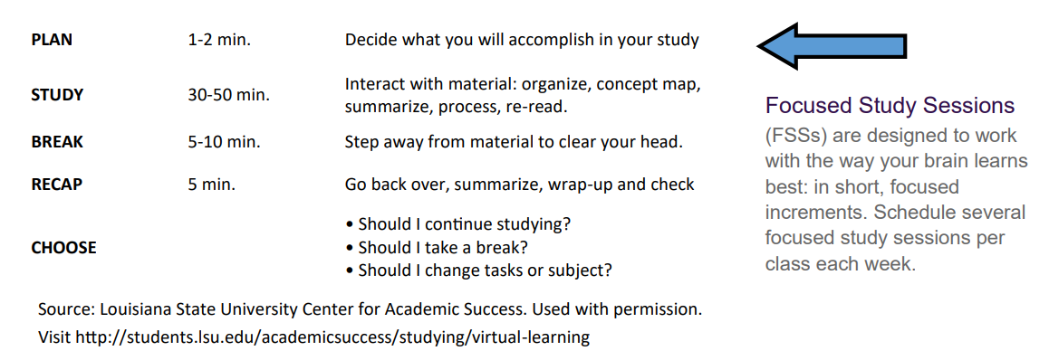

It might also be a good idea to make an appointment with a professional if you also have any of these symptoms, with respect to focus issues:
- Ongoing feelings of sadness, hopelessness, or guilt
- Changes in your sleep habits, such as not being able to sleep or sleeping too much
- Worry or anxiety that’s lasted for months or affects your daily life
- Feeling tired for no reason
- Dry skin, constipation, a puffy face, and/or hoarse voice
- Unintentional weight loss, insomnia, and heat intolerance

FINDING READINGS HARD and How to Deal With It

Some General Tips and Techniques
- General Broad Thoughts: If you’re feeling overwhelmed by the amount of reading you need to complete, break it up into chunks. Choose a moderate amount of material and set yourself the goal of completing it and of working to understand it. Give yourself enough time to do the reading in these chunks, and some extra time in case you feel like you won’t be able to stick to the schedule as rigidly as you would like.
- Skim the reading and get an overview. Read titles, headings, sub-headings, and any summaries or abstracts. Note any graphs, charts, and diagrams. Quickly read the first sentence of each paragraph to get a general idea of what the reading is about. This will help you gauge the reading better when you go through it more closely.
- Read first for what you do understand and don’t get caught up in the difficult parts. Skim over passages that are really difficult and mark or flag what you don’t understand to re-read later. Even a partial understanding will make re-reading easier on your second attempt.
- Ask yourself questions about the reading. Work out what you do understand and what you do not. Try to make connections and associations between what you are reading and what you already know. Revisit the parts you found difficult. How do/ might they fit in with what you do understand?
- It can also be very helpful to write while you read. Underline, make notes, and/or write short summaries that help you concentrate and grasp difficult ideas. Use highlighters, annotate, make notes in the margin— whatever helps you best!
( Here are two helpful guides on what annotation of readings entails and why it is useful:
- https://learningcenter.unc.edu/tips-and-tools/annotating-texts/
- https://research.ewu.edu/writers_c_read_study_strategies )

- There is a chance that you feel like you still don’t get the reading: maybe you cannot focus on the difficult sections, maybe you can’t wrap your head around the idea of the reading, maybe you just really don’t feel like reading. No need to worry: set it aside, and read it again the next day. This gives your brain the chance to process the material. If the reading is still a challenge, talking ideas through often helps. Consult with your tutor or lecturer. Talk about it with other students in the same class.

2. The SQ3R Reading Technique
This reading technique involves five different steps, each one with the goal to get you closer to full comprehension of the text.
- Survey: First survey the piece to get a quick idea of the content and structure of the reading. By doing this, you are preparing your mind.
- Question: Prepare questions for yourself to go over as you read the material. One trick on how to create questions is to turn paragraph titles into questions. For example, a title such as “Women in the Civil War,” could turn into the question: “Who were the women in the civil war, what did they do, and when?”
- Read: Read with your questions in mind. In this step, you can combine other reading techniques that may work for you such as scanning or active reading.
- Recite: Now it is time to go back and answer those questions you created. Make sure what you read makes sense, and that you understand how it answers your questions.
- Review: Make mental notes or say aloud what you have learned. Try doing so without looking at your notes or the text to check what you have or have not retained.
3. The STRUCTURE-PROPOSITION-EVALUATION Technique
Structure-Proposition-Evaluation (SPE) Technique, developed by Mortimer Adler in How to Read a Book (1940), is a structured method to enhance comprehension and critical thinking when engaging with texts. This approach encourages readers to go beyond passive reading by actively analyzing the organization, key arguments, and their own interpretations.

How It Works:
- Structure: Identify the framework of the text. Look at headings, subheadings, and how the content is organized. This helps you understand the author’s intent and how different sections connect.
- Proposition: Determine the main claims or arguments the author is making within each section. What key ideas is the author trying to convey?
- Evaluation: Critically assess these arguments. Do they make sense? Are they well-supported by evidence? Do you agree or disagree, and why?

CONCLUSION AND NOTE FROM TEAM MAA

In this document, we have tried to organize some practical tips, online tools, and resources into four key areas based on the most frequent concerns shared with us. We know this does not cover everything, nor does it claim to be a perfect solution. This is just a starting point—an effort to gather what might help, so you don’t have to look for it alone.
If you are struggling with motivation, overwhelming emotions, feelings of discomfort, difficulty in returning to routine, or anxiety and grief, please know that you do not have to navigate this alone. The Ashoka Centre for Well-Being (ACWB) is available, and we strongly encourage you to reach out to them.
We also recognize that balancing academics in the midst of everything this semester has not been easy. This is why MAA took your concerns forward to the OAA, asking for faculty to be mindful and flexible where possible. If you haven’t read it yet, our email regarding that conversation outlines the options available to you.
This repository is a work in progress, and we are open to suggestions on how it can better support students. If there is anything you think should be included or improved, we would love to hear from you.
At the end of the day, this document is not about fixing everything—it’s about reminding you that help exists, and support is here. Whether through these resources, a friend, ACWB, or a simple conversation, we hope you find what you need. Above all, we just want to check in and say: you are not alone in this.

SOURCES

- https://www.bangkokinternationalhospital.com/health-articles/disease-treatment/brain-fog-syndrome
- https://my.clevelandclinic.org/health/symptoms/brain-fog#care-and-treatment
- https://www.healthline.com/health/brain-fog-anxiety#make-a-plan
- Harvard Health – Exercise and Stress
- Harvard Business Review – 5 Things to Do When You Feel Overwhelmed by Your Workload
- Mayo Clinic – Stress Relief Tips
- https://www.healthline.com/health/unable-to-concentrate#fa-qs
- https://www.bustle.com/p/taking-a-break-by-looking-at-social-media-doesnt-help-your-mind-reset-a-new-study-says-18682642
- https://www.fullerton.edu/learn/_resources/pdfs/print-outs/The%20Study%20Cycle.pdf
- https://www.sciencedirect.com/science/article/abs/pii/S0005796705000495
- https://www.uopeople.edu/blog/reading-techniques/
- https://www.healthline.com/health/unable-to-concentrate#what-to-do
- https://news.yale.edu/2024/10/22/visual-clutter-alters-information-flow-brain
- https://www.webmd.com/add-adhd/why-cant-i-focus
- https://www.todoist.com/inspiration/feynman-technique
- https://www.student.unsw.edu.au/reading-difficult-material

